Universidad Politécnica de Puerto Rico

Lab 4

Benito Camelas Bolas
#6969666
CECS 2203 Sec. 07, WI/13
2 de juliembre de 2013
Prof. Luis Vicente

Introduccion

- Procedimiento.

- Resultados

- Referencias

- Apendice

Procedimiento
Lab 4.1
This program tests whether or not an initialized value is equal to a value input by the user.
Lab 4.2
This program prints "You Pass" if a student's average is 60 or higher and prints "You Fail" otherwise.
Lab 4.3
This program illustrates the use of logical operators.

Lab 4.4
This program illustrates the use of the Switch statement.

Resultados
Lab 4.1
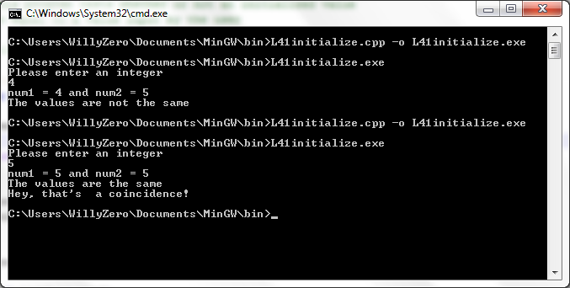
Lab 4.2
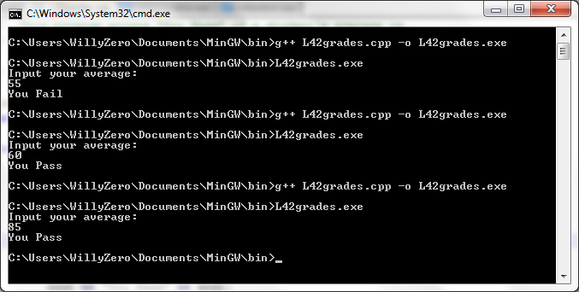

Lab 4.3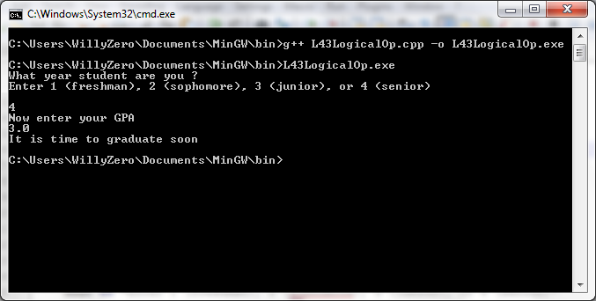
Lab 4.4
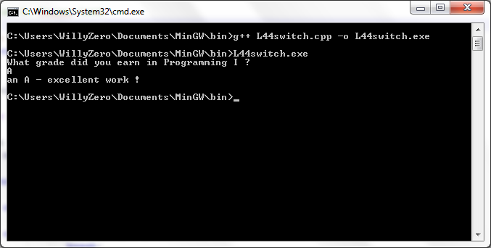

Referencias

L. Vicente. (2013, diciembre 34), [Online]. Available: http://lmvicente.com/cecs2203.htm

Apendice
L41initialize.cpp
// This program tests whether or not an initialized value
// is equal to a value input by the user

// William A. Ferrer Lind

#include <iostream>
using namespace std;

int main( )
{
int num1, // num1 is not initialized
num2 = 5; // num2 has been initialized to 5

cout << "Please enter an integer" << endl;
cin >> num1;

cout << "num1 = " << num1 << " and num2 = " << num2 << endl;

if (num1 == num2)
{
cout << "The values are the same " << endl;
cout << "Hey, that's a coincidence!" << endl;
}
else
{
cout << "The values are not the same" << endl;
}
return 0;
}

L42grades.cpp
// This program prints "You Pass" if a student's average is
// 60 or higher and prints "You Fail" otherwise

// William A. Ferrer Lind

#include <iostream>
using namespace std;

int main()
{

float average; // holds the grade average

cout << "Input your average:" << endl;
cin >> average;

if (average >= 60)
cout << "You Pass" << endl;

if (average < 60)
cout << "You Fail" << endl;

return 0;
}

L43LogicalOP.cpp
// This program illustrates the use of logical operators

// William A. Ferrer Lind

#include <iostream>
using namespace std;

int main()
{
char year;
float gpa;

cout << "What year student are you ?" << endl;
cout << "Enter 1 (freshman), 2 (sophomore), 3 (junior), or 4 (senior)"
<< endl << endl;
cin >> year;

cout << "Now enter your GPA" << endl;
cin >> gpa;

if ( !(gpa <= 2.0) && year == '4')
{
cout << "It is time to graduate soon" << endl;
}
else if(year != '4' || gpa <2.0)
{
cout << "You need more schooling" << endl;
}
return 0;
}

L44switch.cpp
// This program illustrates the use of the Switch statement.

// William A. Ferrer Lind

#include <iostream>
using namespace std;

int main()
{
char grade;

cout << "What grade did you earn in Programming I ?" << endl;
cin >> grade;

switch( grade ) // This is where the switch statement begins
{
case 'A': cout << "an A - excellent work !" << endl;
break;
case 'B': cout << "you got a B - good job" << endl;
break;
case 'C': cout << "earning a C is satisfactory" << endl;
break;
case 'D': cout << "while D is passing, there is a problem" << endl;
break;
case 'F': cout << "you failed - better luck next time" << endl;
break;
default: cout << "You did not enter an A, B, C, D, or F" << endl;
}

return 0;
}

