Universidad Politécnica de Puerto Rico

Lab 31: Bill

Xxxx xxxx xxxx
#12345
CECS 2203 Sec. 07, FA/13
19 de agosto de 2013
Prof. Luis Vicente

Introducction

- Procedure.

- Results

- Apéndix

- References

Procedure
This program will read in the quantity of a particular item and its price.
It will then print out the total price.
The input will come from the keyboard and the output will go to the screen.

Results
(alt+PrtSc copia solamente la ventana activa)
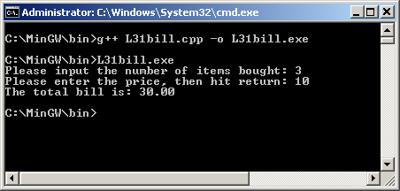

Reference

L. Vicente. (2013, febrero 20), [Online]. Available: http://lmvicente.com/cecs2203.htm

Apéndice

L31bill.cpp
// This program will read in the quantity of a particular item and its price.
// It will then print out the total price.
// The input will come from the keyboard and the output will go to
// the screen.
// Luis M Vicente: #123456

#include <iostream>
#include <iomanip>
using namespace std;
int main(){
int quantity; // contains the amount of items purchased
float itemPrice; // contains the price of each item
float totalBill; // contains the total bill.

cout << setprecision(2) << fixed << showpoint; //formatted output
cout << "Please input the number of items bought: ";

// Fill in the input statement to bring in the quantity.
cin >> quantity;

// Fill in the prompt to ask for the price
cout << "Please enter the price, then hit return: " ;

// Fill in the input statement to bring in the price of each item.
cin >> itemPrice;
// Fill in the assignment statement to determine the total bill.
totalBill = quantity * itemPrice;
// Fill in the output statement to print total bill,
// with a label to the screen.
cout << "The total bill is: " << totalBill << endl ;
return 0;
}

